Digi-T-Y2-19@dom.sandwell.ac.uk
[Company name] [Company address]
DEVELOPMENT DIARY

13/04/2026
On this day I created and incorporated all of my models
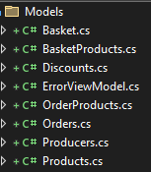
I also seeded my the data for my stuff

System.InvalidOperationException: 'Role ADMIN does not exist.'

